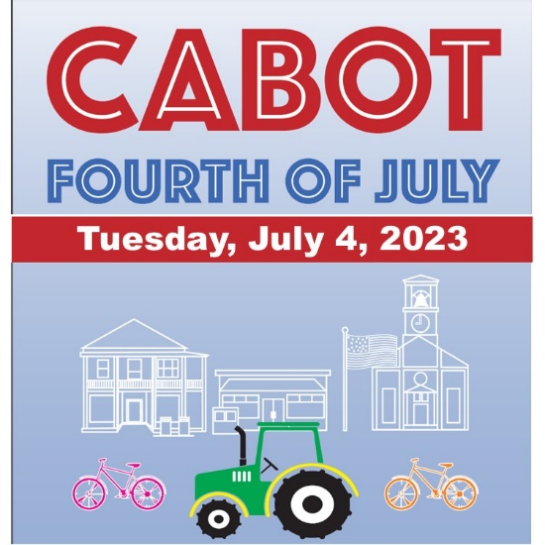
This year’s parade has the theme “Get Outside” to help celebrate all the outdoor activities available to enjoy in Cabot. The parade entries will be judged and cash prizes of $100 are awarded for Cheesiest, most Historic/Patriotic and best “Get Outside” theme.

There is no need to pre-register, but all participants are required to fill out the parade participation form. Additional forms can be downloaded at www.cabotvermont.org.

Parade participants should report before 10:30 am to the
Cabot Fire Department, 2947 Main Street.
Parade starts at 11:00 am.

Parade Participation Form

Name of Entry
Sponsored By
Person in charge/Parent or Guardian for youth entries
Contact Cell Phone # (day of event)
Email
Will you be parking your vehicle after the parade? Please circle one: Yes No

The Cabot 4th of July Committee reserves the right to remove ANY participant from the parade, for misrepresentation, inappropriate conduct, or failure to comply with the Rules of Entry.
RULES OF ENTRY INTO CABOT 4th of JULY PARADE
Parade rules are for the safety and well-being of both the participants and spectators. Agreement to the rules is a requirement for participation. On the day of the parade entries found to be in violation of parade rules may be excluded from judging, may be removed from the parade and/or may be barred from future participation in the Cabot 4th of July Parade.
- For spectator safety, NO THROWING CANDY, HANDOUTS, OR OTHER OBJECTS TO THE CROWD FROM VEHICLES OR FLOATS IN THE PARADE. Walkers may accompany a parade entry and toss candy to spectators.
- At no time shall participants in the parade exit or enter a moving vehicle or trailer.
- All entries must report to the Cabot Volunteer Fire Department at 2947 Main Street, Cabot.
- Community judges will score parade entries to award five $50 cash prizes to the entries chosen in the following categories - Cheesiest, most Agricultural, most Historic, most Patriotic and Judge’s Choice.
- All “entries” are subject to an inspection by Cabot Fire Service personnel prior to parade start time and may be removed from the Parade at their discretion. The decision of the Cabot Fire Service personnel is “final”.
- All drivers of floats, vehicles and fire trucks must possess a valid driver’s license. Youth who would like to drive a motorized vehicle in the parade must be accompanied by an adult.
- All questions and inquiries should be directed to: Lori Augustyniak, CCA Executive Director at 802-279-4309 or by email at Lori@CabotVermont.org.

LIABILITY RELEASE FORM
(This form MUST be signed for you to participate in the Cabot 4th of July Parade)
Your signature indemnifies the Festival Committee, the Town of Cabot, Cabot Community Association & Cabot Fire Department, their employees, officers, sponsors and agents and saves them harmless from all claims, actions, damages, liability and expense in connection with any loss of life, business, injury of any nature, and/or damages to property.
I agree to the rules listed above and understand that event participation is at my own risk.

Signature Date

Name (Please Print)

